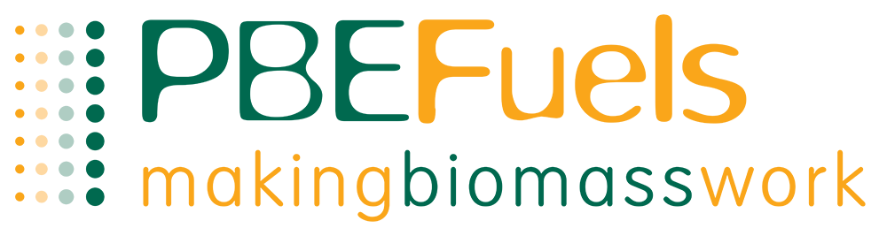
Terms & Conditions for Price match against other companies.
- Has to be a written quotation from within the last 30 days.
- Quotation has to of come from a UK company, operating within our trading area. Our trading area is Wales, South West of England and along the M4 corridor to London. We do go as far as Liverpool and down to Penzance.
- Quote has to be for the product- ENplus A1, BSL authorised biomass wood pellets in bulk blown deliveries.
- Customers who have not previously purchased through us are required to complete a pre-delivery check form, set up an account and payment on order is required before the delivery is made.
- Payment terms of 15 days from when you receive the delivery if previously brought from PBE Fuels Ltd. Payments which breach these terms can incur interest added.
- Offer closes 31st May 2024.
- We reserve the right to decline a delivery or order- this can be due to access conditions, out of trading area.

Telephone: 01437 761320
Email: info@pbe.org.uk

